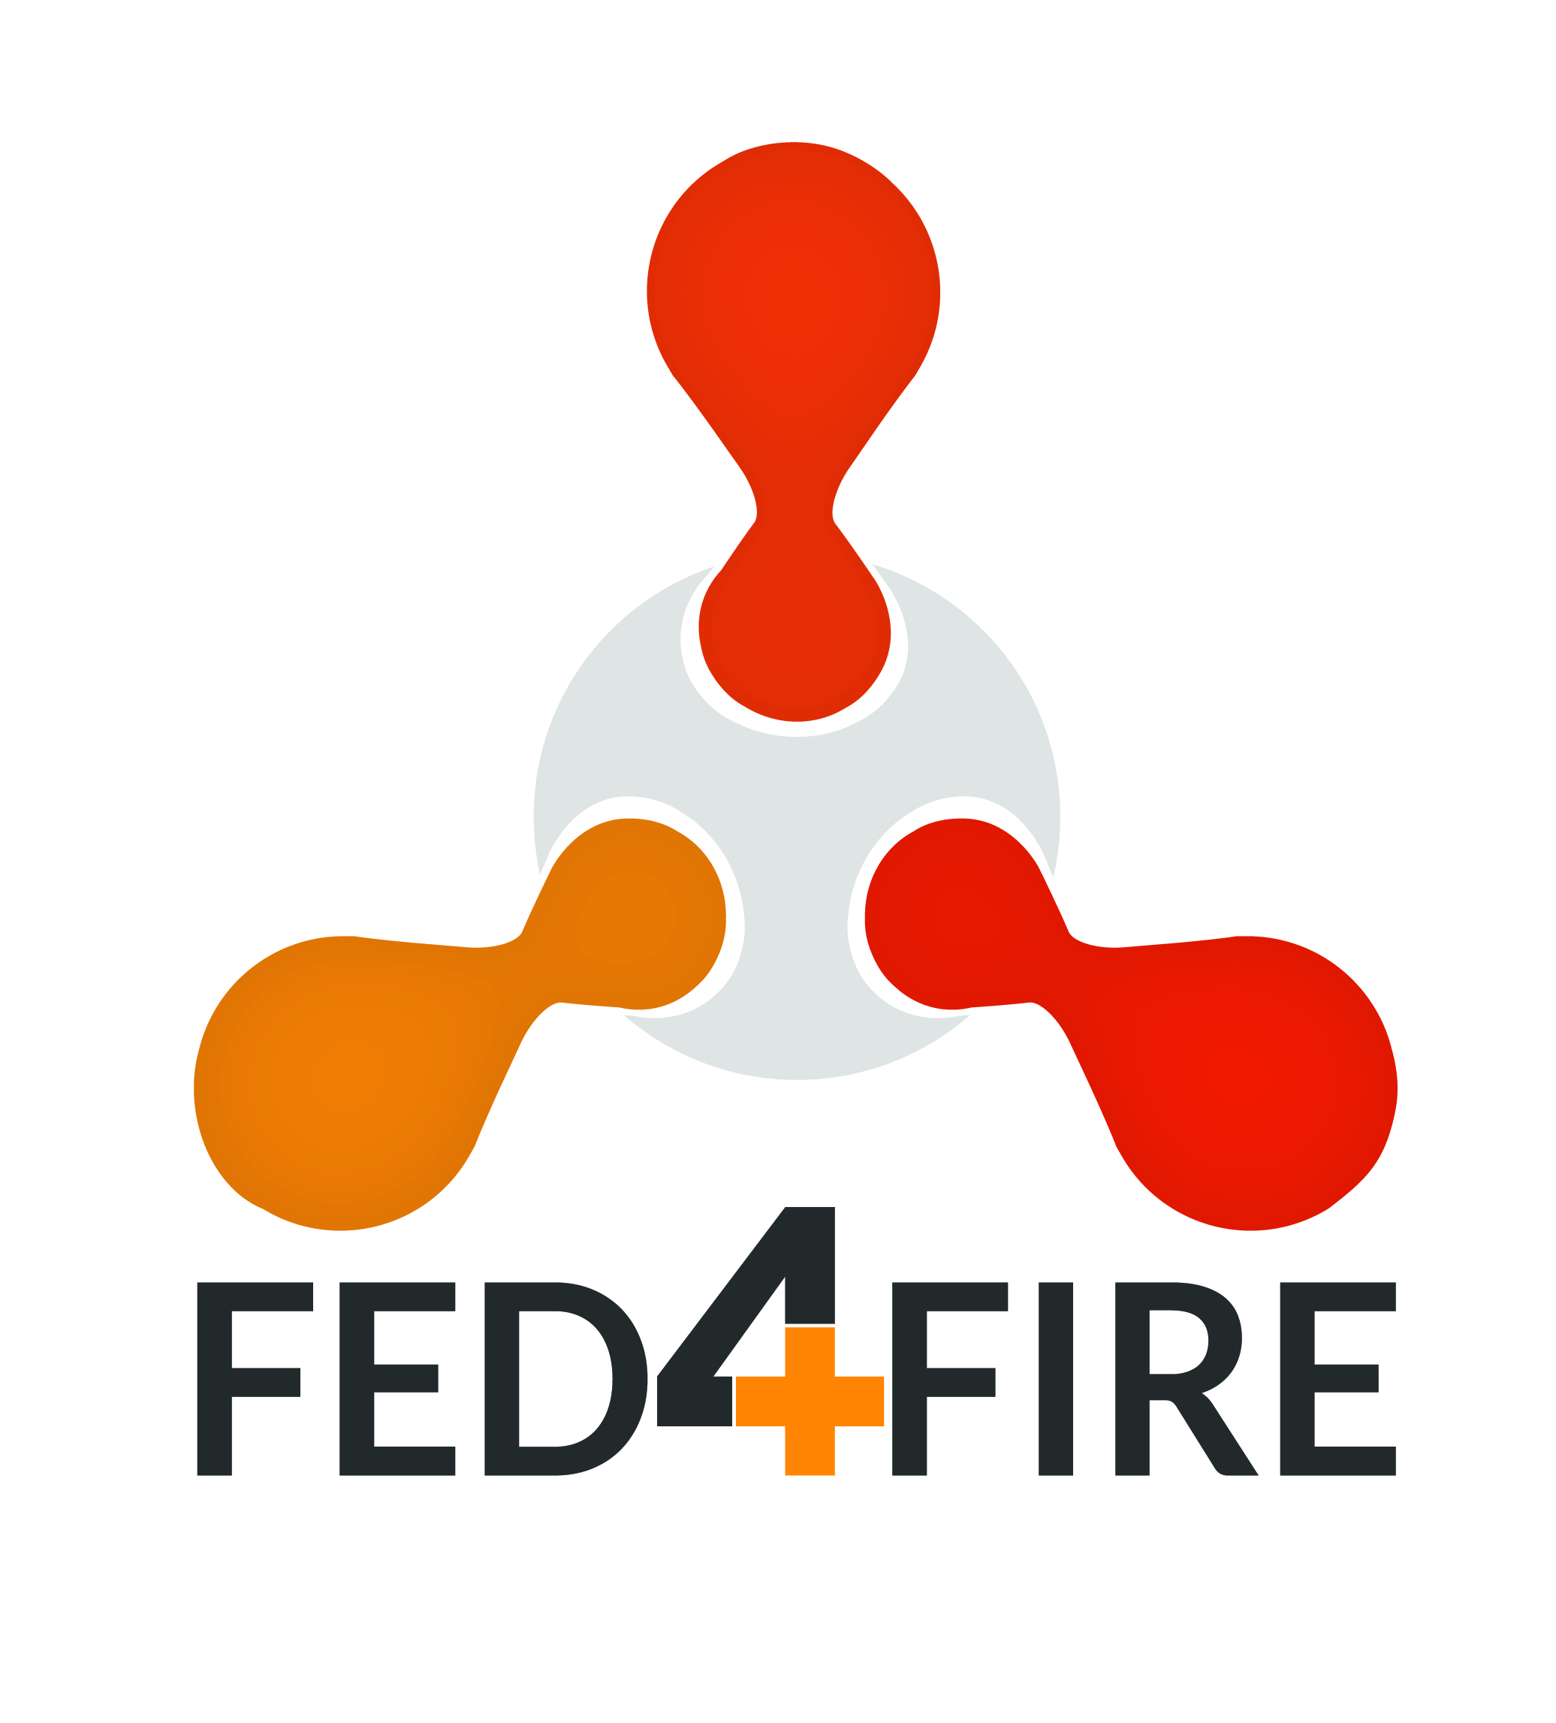 |  |  | 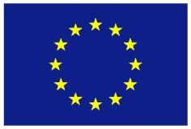

Fed4FIRE+ Experiment Report

Full title of your project
Acronym of your proposal (optional)
Date of preparation of your proposal: xx/yy/202x
Version number (optional):

Your organisation name: Your organisation name
Your organisation address: Your organisation address
Name of the coordinating person: Name of the coordinating person
Coordinator telephone number: Coordinator telephone number
Coordinator email: Coordinator email
(this will be the email address to which the Acknowledgement of Receipt will be sent)

- Project Summary
This section provides an executive summary of the experiment objectives, implementation and main results. Remark: The information in this section will be used in public documents and reports by the Fed4FIRE+ consortium. The length of this section is restricted to 1 page.

- Detailed Description
This section describes the details on the experiment and provides information as you have been collecting this from your point of view and from your business.
- Concept, Objectives, Set-up and Background
There is no page limit for this section as you are invited to describe the concept, objectives and setup in as much detail as you wish to do. Please also include graphs and figures were needed.
    - Concept & objectives
Describe in detail the concept and objectives of your experiment.
    - Set-up of the experiment
Describe in detail the set-up of your experiment. What was the technical design of the experiment? Please include a general overview figure to explain the set-up.
    - Background / Motivation
Situate this experiment in your business or research activity. Why did you want to execute this experiment? How did this experiment fit within the strategy of your company / institution?
- Technical Results & Lessons learned
Describe in detail the technical results of your experiment and the lessons learned.
There is no page limit for this section as you are invited to describe the concept, objectives and setup in as much detail as you wish to do. Please also include graphs and figures were needed.
- Business impact
Describe in detail how this experiment may impact your business and product development.
    - Value perceived
What is the value you have perceived from this experiment (return on investment)?
E.g. gained knowledge; acquired new competences; practical implementation solutions such as scalability, reliability, interoperability; new ideas for experiments/products; etc.
What was the direct or indirect value for your company / institution? What is the time frame this value could be incorporated within your current product(s) range or technical solution? Could you apply your results also to other scenarios, products, industries?
If no federation of testbed infrastructure would be available, how would this have affected your product / solution? What would have been the value of your product / solution if the experiment was not executed within Fed4FIRE+? What problems could have occurred?
Are there any follow-up activities planned by your company/institution? New projects or funding thanks to this experiment? Do you intend to use Fed4FIRE+ facilities again in the future?

    - Funding
Was the allocated budget related to the experiment to be conducted high enough (to execute the experiment, in relation to the value perceived, etc.)?
Did you receive other funding for executing this experiment besides the money from the Fed4FIRE+ Open Call (e.g. internal, national, etc.)?
Would you (have) execute(d) the experiment without receiving any external funding?
Would you even consider paying for running such an experiment? If so, what do you see as most valuable component(s) to pay for (resources, support, etc.)?

- Open Research Data
This section provides feedback on the actions taken by the proposer in the framework of the Open Research Data (ORD) initiative. If you wish to opt out of this initiative (even if you previously opted in), please provide the reasons. If you wish to opt in, please provide DOI of the uploaded dataset, the Final Data Management Plan and all necessary information to show that a complete, publicly accessible dataset of your experiment results and supporting data, has been uploaded in Fed4FIRE+’s chosen repository.
Open Research Data Opt In / Opt Out
Did you provide a complete, publicly-accessible dataset of your experiment results and supporting data, uploaded in Fed4FIRE+’s chosen repository? | YES or NO
For the Answer “NO”: | The experimenter needs to provide reasons why they will not make their experiment data open as part of the proposal. Guidance on opt out reasons can be found in the Open Call Information Document.
For the Answer “YES”: | The experimenter needs upload their data to Fed4IFRE+’s recommended repository (Zenodo - https://zenodo.org/), provide the DOI that Zenodo allocates to identify it, and fill in the following table. This table becomes the Final Data Management Plan, to be submitted with the experiment proposal. Guidance notes are provided in the table. Costs of up to €500 can be claimed by the experimenter for preparation and publishing of ORD. Justification of the claimed costs is required.

Instructions for Uploading
Zenodo https://zenodo.org/ is the recommended Fed4FIRE+ data repository. It is operated by CERN and well used, so it stands a strong chance of long-term archival survival, and it is well-known and easily searchable.
In general, the experimenter makes a zip file of their data and uploads this to Zenodo. Regarding the format, it is up to the experimenter, but the format should be explained within the zip file so that someone else can take the data and use it.
Zenodo is very straightforward to use – the experimenter can create an account (using a standard process), upload the data and give it some description. Some specific notes:
- To upload the data, drag it into the pane or select the files to upload. Make sure you press the “start upload” button on the right, otherwise it will not actually upload the file.
- Specify the type of upload by the radio buttons (most likely this it is a dataset, but there are a few to choose from).
- Zenodo will create a DOI (Digital Object Identifier) for you, which is a unique weblink that you can use to reference the dataset.
- You need a title and some authors – all self-explanatory. If you are an academic and have an ORCID ID, you can put this in the authors section, and it will link to the rest of your ORCID publications (you can also login to Zenodo with your ORCID ID).
- You need a brief description of the data – like an abstract, and some keywords. Each keyword goes in a box on its own - you can’t just separate them by commas.
- Re license – if you are happy for anyone to use it for any purpose, “Creative Commons Attribution” is a reasonable choice – this means anyone can use it, as long as you are acknowledged as the author. There are other options as well – if you want to discuss them, please contact sjt@it-innovation.soton.ac.uk for help.
- For the funding section, put European Commission (EU) and the Fed4FIRE+ grant number is 732638. This is very important!
- You need to “save” the record (it is suggested that you keep doing this) before publication, and when you are ready to publish, hit “publish”.
- Once you have published, it is not obvious how you see your own published items – you can do this by selecting “Upload” in the main menu bar at the top of the page.
Once upload is completed, please fill in the following table, which comprises the final data management plan. Simply replace the text in the green boxes with your information.
Final Data Management Plan
Sect-ion | DMP Category and Question | Final DMP | Fed4FIRE+ Guidance Notes
 |  |  | Y = mandatory to answer question, O = optional to answer, N/A = not applicable
0 | Experiment Information
 | Name of Experiment | Y
 | Names of Experimenters | Y
 | Experimenters' Organisations | Y
 | Fed4FIRE+ Call ID | Y
 | Experiment Start Date | Y
 | Experiment End Date | Y
 | Fed4FIRE+ Testbeds | Y
 | Fed4FIRE+ Sponsor | Y
 | DOI of uploaded dataset | Y | Digital Object Identifier issued by Zenodo after upload.
1 | Data Summary
 | What is the purpose of the data collection/generation and its relation to the objectives of the project? | Y | This should be the abstract of experiment from proposal including objectives of collecting the experiment data.
 | What types and formats of data will the project generate/collect? | Y | Initially this can be an estimate. In the final DMP this should be a statement of the formats, so it can go into the metadata.
 | Will you re-use any existing data and how? | Y | If any external data is anticipated before the experiment starts, state it here. If any external data has been used during an experiment, it must be stated, along with any license terms or stipulations.
 | What is the origin of the data? | Y | This is the expected source of the data before the experiment runs, and the actual source of data once the experiment is complete.
 | What is the expected size of the data? | Y | Initially this can be an estimate. In the final DMP this should be the actual size of the data.
2 | FAIR data
2.1 | Making data findable, including provisions for metadata
 | Are the data produced and/or used in the project discoverable with metadata, identifiable and locatable by means of a standard identification mechanism (e.g. persistent and unique identifiers such as Digital Object Identifiers)? | Y | Initially, this should be a statement committing that the experiment data will be discoverable. When the experiment is complete, the experiment data's Digital Object Identifier (DOI) and metadata should be cited.  Fed4FIRE+'s repository of choice, Zenodo, allocates a DOI at upload time, and allows keywords to be entered into a form. These keywords will form part of the metadata that allow the data to be discoverable.
 | What naming conventions do you follow? | Y | Initially this can be optional, although it is recommended to think of the naming conventions before the data is collected. After the experiment, this should cite the naming conventions used.
 | Will search keywords be provided that optimize possibilities for re-use? | Y | This should always be YES - there will be or are keywords for search terms. The keywords should be stated here.
2.2 | Making data openly accessible
 | What methods or software tools are needed to access the data? | O | If there are any special tools or methods needed to access the data (e.g. commercial software tools that can open the data's format), state them here.
 | Is documentation about the software needed to access the data included? | O | If software tools are needed, cite the documentation.
 | Is it possible to include the relevant software (e.g. in open source code)? | O | If possible, include or cite the software tools (e.g. sourceforge location)
2.3 | Making data interoperable
 | Are the data produced in the project interoperable, that is allowing data exchange and re-use between researchers, institutions, organisations, countries, etc. (i.e. adhering to standards for formats, as much as possible compliant with available (open) software applications, and in particular facilitating re-combinations with different datasets from different origins)? | Y | The default position for Fed4FIRE+ is "yes - the data will be (or is) interoperable". This section should be a statement of commitment by the experimenter that the data will be (or is) interoperable.
 | What data and metadata vocabularies, standards or methodologies will you follow to make your data interoperable? | Y | Initially, this should be a statement of the formats intended for the data, together with citations of their definitions if applicable (e.g. RFCs etc.). For metadata, the experimenter should cite the anticipated metadata schemas by URL. After the experiment is complete, it should be a statement of the actual formats used, as well as citations to metadata schemas.
2.4 | Increase data re-use (through clarifying licences)
 | How will the data be licensed to permit the widest re-use possible? | Y | Initially, this should be a statement of the intended license, which at least must permit open access. Once the experiment is complete, the data must be licensed under terms that permit open access, and the license must be named here. The default license is Creative Commons CC-BY 4.0, and open license that provides attribution of the creator.
 | Are data quality assurance processes described? | O | If any QA procedures are observed, they should be stated - it is in the interest of the experimenter to describe these, as they will help the reusability of the data.
3 | Allocation of resources
 | Who will be responsible for data management in your project? | Y | The person responsible for the data management should be named in both the initial and final DMP. This should be the principal experimenter.
4 | Data security | N/A | Responsibility of Repository
5 | Ethical aspects
 | Are there any ethical or legal issues that can have an impact on data sharing? These can also be discussed in the context of the ethics review. If relevant, include references to ethics deliverables and ethics chapter in the Description of the Action (DoA). | Y | Legal, ethical and data protection issues must to be described in the initial DMP that forms part of the experimenter's proposal before the experiment runs, together with procedures for correct compliance with the applicable laws including the implications of storing the data for the long term in an open repository.
 | Is informed consent for data sharing and long term preservation included in questionnaires dealing with personal data? | Y | The experimenter must specify methods for acquiring informed consent in their initial DMP.
6 | Other issues
 | Do you make use of other national/funder/sectorial/departmental procedures for data management? If yes, which ones? | O | If other DMP procedures are used, the experimenter should state them.
7 | Cost Claim
 | Please state the costs you incurred as a result of preparing Open Research Data | O | Costs of up to EUR 500 can be claimed, so please put the amount you wish to claim here
 | Please provide justification & evidence for the amount you are claiming (e.g. describe the research, attach any receipts etc) | O

- Feedback to Fed4FIRE+
This section contains valuable information for the Fed4FIRE+ consortium and describes your experiences by running your experiment on the available testbeds. Note that the production of this feedback is one of the key motivations for the existence of the Fed4FIRE+ Open Calls.
- Resources & tools used
    - Resources
Describe the testbeds you have been using and specify the resources used.
Please use www.fedfire.eu to get details on the specific testbeds or contact@Fed4FIRE.eu
Wired networking testbeds |  |  | Used? | Specify the type and amount of the resources used
 | Virtual Wall (imec)
 | PL-LAB (PSNC)
Wireless/5G/IoT testbeds
 | w-iLab.t (imec)
 | Portable wireless testbed (imec)
 | CityLab (imec)
 | NITOS (UTH)
 | Netmode (NTUA)
 | SmartSantander (UC)
 | Triangle/PerformLTE (UMA)
 | IRIS (TCD)
 | LOG-a-TEC (JSI)
 | R2lab (Inria)
 | IoTLab (Mandat)
OpenFlow testbeds
 | i2CAT OFELIA island
 | NITOS (UTH)
 | Virtual Wall (imec)
 | Grid5000 (Inria)
Cloud computing testbed
 | Virtual Wall (including GPUlab) (imec)
 | Exogeni (UvA)
 | Grid5000 (Inria)
Other
 | Tengu – big data (imec)

Did you make use of all requested testbed infrastructure resources, as specified in your Open Call proposal? If not, please explain.
What was the ratio between time reserved vs time actually used for each resource? Why does it differ that much (e.g. for interference reasons, other)?
    - Tools
Describe in detail the tools you have been using, resources used, how many nodes, etc.
Tools | Used? | Please indicate your experience with the tools. What were the positive aspects? What didn’t work?
JFed
JFed command Line (CLI)
Omni
OMF
NEPI
OML
Please list below other tools used

- Feedback based on design/set-up/running your experiment on Fed4FIRE+
Describe in detail your experiences concerning the procedure and administration, set-up, Fed4FIRE+ portfolio, documentation and support, experimentation environment, and experimentation execution and results. This feedback will help us for future improvement.
    - Procedure / Administration
How do you rate the level of work for administration / feedback / writing documents / attending conference calls or meetings compared to the timeframe of the experiment?
    - Setup of the experiment
How much effort was required to set up and run the experiment for the first time? Did you need to install additional components before you were able to execute the experiment (e.g. install hardware / software components)?
How do your rate the experience as user that you only had to deal with a single service provider (i.e. single point of contact and service) instead of dealing with each testbed itself?
    - Fed4FIRE+ portfolio
Was the current portfolio of testbeds provided by the federation, with access to a large set of different technologies (sensors, computing, network, etc.) provided by a large amount of testbeds, sufficient to run your experiment?
Was the technical offering in line with the expectations? What were the positive and negative aspects? Which requirements could not be fulfilled?
Could you easily access the requested testbed infrastructures?
Could you make use of all requested resources at the different testbeds as was proposed in the description of the experiment? If not, how many times did this fail? What were the main reasons it failed (e.g. timing constraints, technical failures, etc.)?
Did you use a lot the combination of resources over different testbeds? Did it all work out nicely? Were they interoperable?
    - Documentation and support
Was the documentation provided helpful for setting up and running the experiment? Was it complete? What was missing? What could be updated/extended?
Did you make use of the first level support dashboard?
Did you contact the individual testbeds for dedicated technical questions?

    - Experiment environment
Was the environment trustworthy enough for your experiments (in terms of data protection, privacy guarantees of yourself and your experiment)?
Did you have enough control of the environment to repeat the experiment in an easy manner?
Did you experience that the Fed4FIRE+ environment is unique for experimentation and goes beyond the lab environment and enables real world implementation?
Did you share your experiment and/or results with a wider community of experimenters (e.g. for greater impact of results, shared dissemination, possibility to share experience and knowledge with other experimenters)? If not, would you consider this in the future?
    - Experiment execution and results
Did you have enough time to conduct the experiment?
Were the results below / in line with / exceeding your initial goals and expectations?
What were the hurdles / bottlenecks? What could not be executed? Was this due to technical limits? Would the federation or the individual testbeds be able to help you solving this problem in the future?
    - Other feedback
If you have other feedback or comments not discussed before related to the design, set-up and execution of your experiment, please note them below.
- Why Fed4FIRE+ was useful to you
Describe why you chose Fed4FIRE+ for your experiment, which components were perceived as most valuable for the federation, and your opinion what you would like to have had, what should be changed or was missing.
    - Execution of the experiment
Why did you choose Fed4FIRE+ for your experiment? Was it the availability of budget, easy procedure, possibility to combine different (geographically spread) facilities, access to resources that otherwise would not be affordable, availability of tools, etc.? Please specify in detail.
Could you have conducted the experiment at a commercially available testbed infrastructure?
    - Added value of Fed4FIRE+
Which components did you see as highly valuable for the federation (e.g. combining infrastructures, diversity of available resources, tools offered, support and documentation, easy setup of experiments, etc.)? Please rank them in order of importance.
Which of these tools and components should the federation at least offer to allow experimentation without funding?
    - What is missing from your perspective?
What would you have liked to have had within Fed4FIRE+ (tools, APIs, scripts, etc.)? Which tools and procedures should be adapted? What functionality did you really miss?
Which (types of) testbed infrastructures (and resources) would have been very valuable for you as an experimenter within the Fed4FIRE+ consortium?
Is there any other kind of support that you would expect from the federation, which is not available today e.g. some kind of consultancy service that can guide you through every step of the process of transforming your idea into an actual successful experiment and eventually helping you to understand the obtained results?

    - Other feedback
If you have further feedback or comments not discussed before how Fed4FIRE+ was useful to you, please note them below.
    - Quote
We would also like to have a quote we could use for further dissemination activities. Please complete the following sentence.
Thanks to the experiment I conducted within Fed4FIRE+ ...

